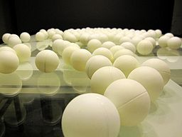
What is inquiry?
1.

2.

3.

The 5 Es of Inquiry

Engage
Explore
Explain
Elaborate
Evaluate

